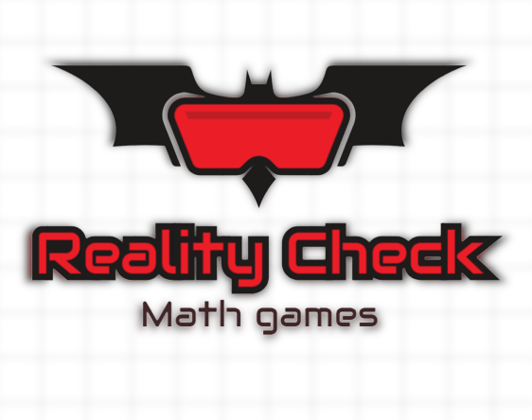

**Introduction:**

Contents

TEST PLAN 3

Introduction 3

Entry and exit criteria 3

ENTRY CRITERIA 3

EXIT CRITERIA 3

OBJECTIVES 4

OBJECTIVES 4

APROACH 4

SCOPE 4

TESTING PROCESS 4

TEST DELIVERABLES 4

RESOURCES 5

RESOURCES 5

# TEST PLAN

## Introduction

This is a document which provides a plan for testing our word game project. Our game contains interactive battles about correct word writing and math questions with NPCs and a shop.

## Entry and exit criteria

### ENTRY CRITERIA

• Code development has been paused until QA testing is finished

• High quality of back-end development

• High quality of source code

### EXIT CRITERIA

• All test cases are passed successfully

• There are no critical issues which ruin the playing experience

## OBJECTIVES

### OBJECTIVES

• The objectives of this testing process are to verify that all of the code work properly and do not have any major bugs or issues

## APROACH

### SCOPE

• Manual testing

o Game interface

o Menu options

o Game function algorithms

## TESTING PROCESS

### TEST DELIVERABLES

• Excel file with description of the test suits filled with different test cases

## RESOURCES

### RESOURCES

• Excel as test case management tool

• GitHub for reporting problems with issues